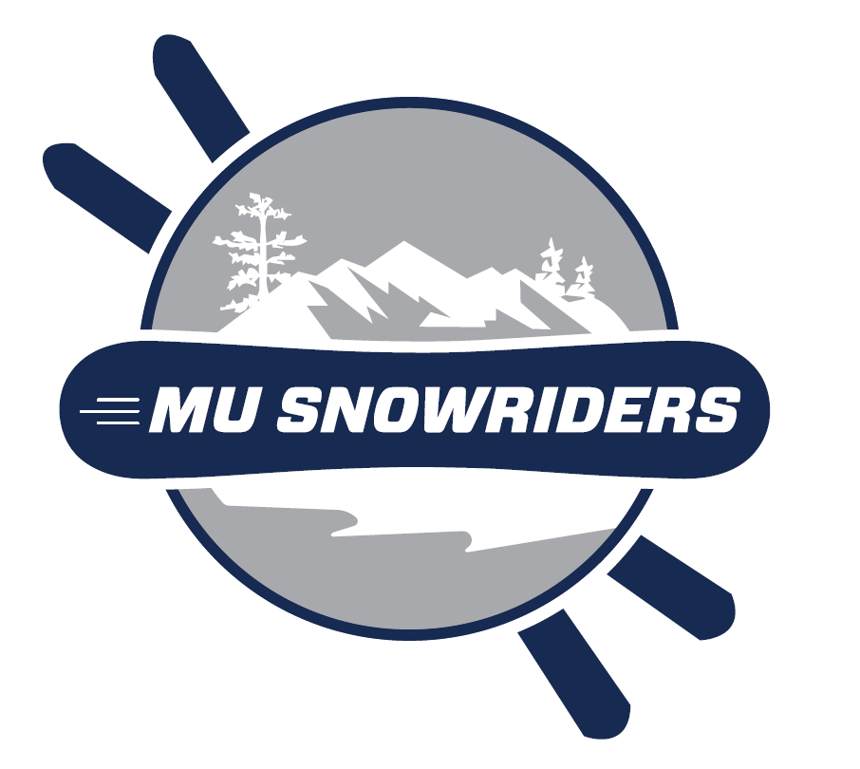
  Tremblant – Jan 11-16, 2026
  (Sunday-Friday)

overview & general information
- $899 per student and for guests. One guest (age 18+) per student allowed, space permitting (rare for single-bus Tremblant trips, but possible). Students are responsible for their guests.
Students that have an IKON PASS enjoy a $180 discount off this price.
- Travel by bus on Sunday January 11, 2026 7AM-7PM to Tremblant, QC. Stay 5 nights on the mountain. Travel by bus back on Friday January 16, 2026 9AM-8PM. Travel time includes 3 stops for food/bathroom/border. Exact travel time usually varies +/- 1 hour based on weather, traffic and border inspection activity. Stops may be changed/skipped due to unexpected events.
- Online sign up will begin on MONDAY October 6, 2025 @ 10PM. An email will go out to everyone on the Snowriders email group at 10 pm with the link for sign-ups to begin. This is on a first-come, first-served basis, so sign up early if you are committed to going.
- PASSPORT or PASSPORT CARD IS REQUIRED TO BOARD THE BUS. HAVE IT ON YOUR PERSON AT ALL TIMES. If you need a passport or passport card, apply AT LEAST 8 weeks in advance of the trip. The cost is $165 / $65, respectively, as of 2025. NOTE: Passport card is only usable for land or sea travel (not air) to Canada, Mexico, and some Caribbean countries.
- When you pay online, you MUST sign and agree to the terms on the Assumption of Risk and Release form and give emergency contact information before payment will be accepted. Forms need to be emailed to bgrowney@monmouth.edu, and all pages need to be initialed. Questions about the Assumption of Risk and Release form should be directed to the Office of the General Counsel @ (732) 571-3598.
- Medical insurance is part of the price you pay. Generally, anything involving a doctor/medication/X-rays is covered.
- There are NO REFUNDS. If you cannot make the trip, please contact us so we can TRY to find you a replacement for your spot. We strongly recommend that you purchase travel insurance on your own to avoid this situation. Travelguard.com or InsureMyTrip.com are good places to start.

Before you go
- You may pack 1 suitcase, 1 board/ski bag, 1 boot bag, and 1 carry-on. Storage space is ALWAYS FULL, so PLEASE DON’T OVERPACK.
  - NOTE: There is an indoor & outdoor hot tub; bring a bathing suit.
  - NOTE: Temperatures may reach -30ºF at night. Bring appropriate evening wear.
  - NOTE: YOUR PASSPORT MUST BE ON YOU TO BOARD THE BUS.

- NO alcohol or drugs (including weed/marijuana) is allowed on the bus AT ANY TIME! Ask us about the time we were stopped and delayed 2 hours when Canadian agents found weed. You WILL be left at the border if there are problems. This is a University club-sponsored trip – the Student Code of Conduct applies.

- Park at Woods Theater (Lot #23). This is at the corner of Norwood and Cedar Ave.

- Bus will be waiting at MUPD/Woods Theater from 6-7AM. Departure is at 7 AM sharp. You MUST contact Nikita Pospelov (President) at (732) 915.0488 if you will be slightly late; else, we WILL leave without you!

- You MUST keep your passport ON YOU while on the bus (not stowed with luggage under the bus).

- You SHOULD have a credit card with at least a $1500 limit in case you are injured. Insurance is NOT accepted in Canada. Payment for ANY medical service is due up front!! Talk to your carrier before the trip! The fee to be looked at by the clinic on the mountain, with x-rays, was about $700 in 2025.

- If you have a debit/credit card, be aware of “Foreign Transaction Fees”. Not all card types from a particular bank will have this fee. The fees typically range from 2.5-3.0% of all purchases.

- Talk to your cell phone provider about an International Plan. Voice and Data charges are EXTREMELY EXPENSIVE (like $100’s for a week) without a plan. Add-on plans can be as low as $10/day.

The ride up
- The bus SHOULD have Wi-Fi, electric, and TVs hooked up to a DVD player.

- The bus SHOULD be operating close to this schedule. Do NOT lollygag at the stops; come back to the bus as soon as possible. The sooner we reassemble, the sooner we can be on our way and reach Tremblant.
  - 7:00 AM: Depart Monmouth
  - 8:25 AM: Arrive at Sloatsburg rest area on the NY Thruway (Sloatsburg, NY)
    - Change to a new bus driver. -QUICK STOP- for us while he does his paperwork.
    - Bathroom, Dunkin Donuts, Starbucks, BK. Order ahead on an app!!
Expected departure: 9:10 AM
  - 11:15 AM: Arrive at Rest Area for bathroom break only (Clifton Park, NY)
    - This is a quick 15-minute stop. Expected departure: 11:30 AM
  - 1:45 PM: Arrive at Chipotle/Panera/Buffalo Wild Wings/Five Guys/Chick-Fil-A (Plattsburgh, NY)
    - Please order ahead of time via apps. We’ll give you sufficient notice while on the bus. Lines are too long without doing this! Buses will stop at Chipotle/BWW and drop people off, then go to Panera/5 Guys/Chick-fil-A. They’ll return to pick up the first group after an hour. Expected departure: 2:50 PM
  - 3:15 PM: Arrive at Canadian border (St. Bernard de la Colle, QC)
    - Agents will call us in as a group and will indicate whether to leave or take our carry-ons.
    - They may/will search (possibly with dogs) while we are offloaded, and we will be interviewed separately.
    - Answer the agent’s questions honestly and fully. Do not give any more or less information than what they ask. They are human lie detectors, and they do this all day, every day. They do NOT have to let you in. “Yes, sir, no sir” is appropriate.
    - Expected Departure: 3:55 PM (shorter if no buses are before us in line)
  - 6:10 PM: Arrive at IGA Supermarket (Mont-Tremblant, QC)
    - This is like the Whole Foods of Canada.
    - WARNING: Alcohol is still not permitted on the bus.
    - Save money and make your food for the week, you will have access to a kitchen. There IS a convenience store at the mountain if you run short, along with many restaurants.
    - Remember: You are paying in CAD. Mentally subtract 25% from the prices.
    - Expected departure: 7:05 PM (1hr in IGA)
  - 7:30 PM: Arrive at hotel. BRING YOUR TRASH TO THE FRONT OF THE BUS WHILE WE WAIT!

arrival & while you’re there
- You will be staying at: (Exact Room numbers will be given on the busl)
Lodge de la Montagne (819)-681-4466
140 Chemin au Pied de la Montagne
Mont-Tremblant, QC J8E 3M2
Canada
- ONE person from each room will be required to give a credit card for the security deposit. Hotel Staff WILL inspect your room and assess damage fees. DO NOT smoke [anything] in the rooms. DO NOT wax your equipment in the room. Don’t let your deposit go up in smoke!

- The depositor will receive the room package (key cards, equipment locker room locks, and hotel rules) upon check-in. The 4-Day Lift ticket must be picked up by the room leader OR by everyone individually in the Hotel’s BACK LOBBY.

- Ski equipment MUST be stored in the lockers on the lower level of the hotel. Lodge de la Montagne is ski-in/ski-out.

- You MUST keep hallway noise to a minimum AND your room doors MUST NOT be left open.

- There ARE security guards on ALL floors in the evening/overnight to enforce this. You do not want to be fined or removed from the hotel.

- ATM: The General Store & The Forge restaurant on the mountain has an ATM. Wi-Fi: Free. Cards are accepted everywhere, but cash may be convenient to leave tips for waiters, etc.

- You are a GUEST in another country. Act respectfully as you are representing Monmouth University and the United States. You are subject to their laws and their customs. Try to have a “buddy” that you are going to be with throughout the trip. Be helpful and look after one another.

on the mountain
- Helmets are HIGHLY ENCOURAGED, but only REQUIRED for the terrain parks.

- Group lessons are available for $125 in the AM (9:00-noon), $115 in the PM (1PM-3:15) or Full Day for $240. You may want to book lessons on the Tremblant.ca website ahead of time.

- Daily equipment rentals are available at the mountain, but it is cheaper if you order ahead of time (before November 28) on the Tremblant website. The pre-Nov 28 prices are $85 USD/day with tax (about $15.50 USD/day, that’s about $402 for the trip). Post-November 28, the price increases.

- A restaurant/bar/shopping location list can be found at: http://www.tremblant.ca/lodging-and-village/village

- Ice skating (all afternoon) (ice permitting). Casino is open only on Thursday evening (18 to gamble).

The Ride Home
- Check-out begins at 7 AM. The bus arrives at 8 AM and the bus will LEAVE at 9 AM. Your room should be left the way you found it. It WILL be inspected by hotel staff before you leave!!

- You MUST have your passport on you while on the bus! We will check before departure!!
  - 9:00 AM: Depart Mont-Tremblant
  - 11:35 AM: Arrive at US Border (Champlain, NY)
    - Agents will usually board the bus to collect our passports, though we may be called off and interviewed separately. If you are a US Citizen, they must let you in. If you are not a U.S. citizen, they may let you in. Have your passport open and ready, and be courteous!
    - Agents will usually ask questions to the driver and advisors, then leave with our passports. Unless there is a problem with someone’s passport, they will hand the stack back to us, and we will distribute them.
    - Expected departure: 12:15 PM
  - 12:45 PM: Arrive at Consumer Square (Plattsburgh, NY)
    - Bathrooms, Chipotle, Wendy’s, Panera, Buffalo Wild Wings, Walmart.
    - We’ll announce our arrival time once we leave the border. Use an app to order ahead!
    - Expected Departure: 2:00 PM
  - 3:45 PM: Arrive at Glens Falls Rest Area (Glens Falls, NY)
    - Bathroom break only. 15-minute quick stop.
    - Expected Departure: 4:00 PM
  - 6:35 PM: Arrive at Ramapo Rest Area (Sloatsburg, NY)
    - Change to a new bus driver. -QUICK STOP- for us while he does his paperwork.
    - Dunkin Donuts, BK, Starbucks
    - Expected Departure: 5:00 PM
  - 8:30 PM: Arrive at Monmouth - BRING YOUR TRASH TO THE FRONT OF THE BUS!

IMPORTANT legal and safety INFORMATION
- Alcohol SHALL NOT be brought on the bus at any time.

- Quebec’s legal age of consumption is 18. Students are strongly encouraged to use good judgment and know their limits of consuming alcohol. If you plan to drink, drink moderately. Do NOT endanger yourself, others, property, or the future opportunity for the SnowRiders to be permitted to participate in this trip again. You paid good money to be on the trip, enjoy the mountain, not the hangover.

Marijuana is legal in all of Canada, but you need to know the rules. It is illegal to: a) have more than 30 grams in public, b) import it into Canada, c) give to minors, d) sell to anyone, e) smoke (includes cigarettes and e-cigs) within 30 feet of any door, window, air intake of any building open to the public (e.g. bars, restaurants, hotels). Additionally, do NOT return to the U.S. with it as the federal government (the border agents) still consider it illegal. You must be 21 to purchase/consume.

- Look out for each other and keep each other safe. Also, “Know the Code” http:/www.nsaa.org/safety-programs/responsibility-code/

- If you notice that a student is incapacitated due to alcohol overuse or needs medical attention, you are strongly encouraged to make the responsible choice to immediately contact a local emergency medical service and any of the trip advisors to protect the health and well-being of the affected student.

- Students must comply with Monmouth University’s policies for student conduct (including, without limitation, those outlined in the Student Code of Conduct in the Student Handbook and any specific Trip materials). You understand that if you violate any of Monmouth University’s policies and standards for student conduct, the laws of Canada, the instructions and guidelines given to you by any of the trip advisors, or otherwise demonstrate behavior which is detrimental to the group or the program, you may be sent home at your own expense and may be charged under the Student Code of Conduct.

SEXUAL MISCONDUCT
Monmouth University prohibits any forms of sexual misconduct. Should you experience an act of sexual misconduct or become aware that any member of your group has experienced an act of sexual misconduct, please notify a trip advisor immediately. Your Lead Trip Advisor, Barbara Growney, can be reached any time at: bgrowney@monmouth.edu or (908)-361-4828 (cell). For international trips, e-mail or text works best. If necessary, seek immediate medical attention. Please be aware that should an incident of sexual misconduct occur to you or anyone in your group, the options available include:

- Meeting with local law enforcement to file charges. Mont-Tremblant police’s telephone number is 9-1-1 or (819)-425-2723.
- Meeting with the Office of Student Life to file a complaint under the Student Code of Conduct and/or request interim measures.
- A student may choose to take advantage of any or all of these options simultaneously.
- A student may choose not to pursue any of these options.
RESOURCES:
- Office of Equity and Diversity/Title IX Coordinator: (732) 571-7577
- Office of Student Life: (732) 571-3417
- Monmouth University Counseling and Psychological Services (Confidential Resource): (732) 571-7517
- Monmouth University Health Services (Confidential Resource): (732) 571-3464

Important contact information
Snowriders Club |  | snowride@monmouth.edu
Club President | Nikita Pospelov | s1359520@monmouth.edu | (732) 915-0488
Club Advisor | Barbara Growney | bgrowney@monmouth.edu | (908)-361-4828
Trip Advisor #2 | Michael Wunsch | mwunsch@monmouth.edu | (732) 778.0305
Lodge de la Montagne (hotel) |  |  | (819)-681-4466
Pharmacy (Family Prix) [they deliver] |  |  | (819)-425-6661

